Rabbits - Medium Term Planning - Music Summer 1 2024
Topic: Off on an Adventure  Anyone can play: Introducing March  Musical Elements: playing, listening, responding, moving to music. | Music this term will be based around the scheme from Charanga, ‘Introducing March’. The children will recap their knowledge of repeating patterns and rhythm as they attempt to keep the beat on a marching song.  Continuous provision will also enhance the opportunities to explore music and sound on a daily basis.  (Learn Makaton with all songs and nursery rhymes)

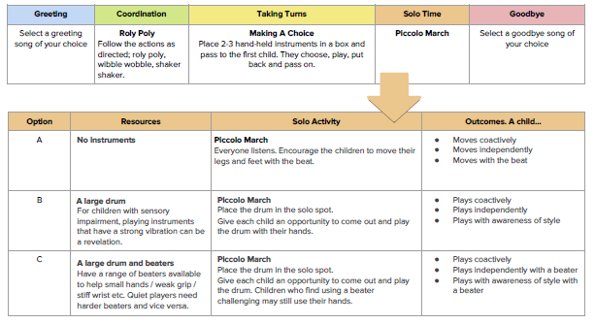
Week 1 –
Recap repeating patterns through the ‘Shake, Shake, Wait’ song.
Introduce the song ‘The Ants go Marching’ – encourage children to listen to the song and move in time with the beat. Can they clap the beat? Can they march in time with the beat?

Week 2 –
Listen to the song ‘The Ants go Marching’ to begin with. Start to introduce instruments to play alongside the song, i.e. the drum.

Week 3 – 5 –
Listen to the song ‘The Ants go Marching’ to begin with. Have a selection of instruments for the children to choose from. Allow them to practice keeping the beat with their chosen instrument. Can they play their instrument in pairs?
Week 6 –
Listen to the song ‘The Ants go Marching’ to begin with. Can the children perform with their instrument independently?

Take the objectives for the LO stickers from this section
Substantive Knowledge (Content) | Disciplinary Knowledge (Skills)
Children sing a range of well-known nursery rhymes and songs. Children perform songs, rhymes, poems and stories with others, and (when appropriate) try to move in time with music. | Development Matters:  - Show attention to sounds and music.  - Respond emotionally and physically to music when it changes.  - Move and dance to music.  - Anticipate phrases and actions in rhymes and songs, like ‘Peepo’.  - Explore their voices and enjoy making sounds.  - Join in with songs and rhymes, making some sounds.  - Make rhythmical and repetitive sounds.  - Explore a range of soundmakers and instruments and play them in different ways.  - Enjoy and take part in action songs, such as ‘Twinkle, Twinkle Little Star’.  - Listen with increased attention to sounds.  - Explore and engage in music making and dance, performing solo or in groups.

