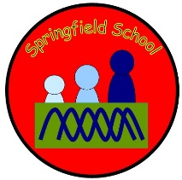
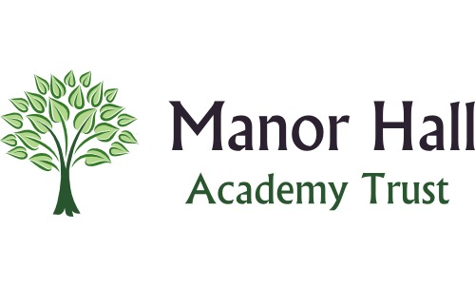

Springfield Road
Leek

Dear Parent/Carer,
As your children have settled into school so well and have worked really hard since September, we will be going to Santa’s Grotto at Beaver Hall as an end of term treat on Thursday 14th December. During the trip the children in Hedgehogs class will see Santa where they will receive a gift, help Mrs. Claus decorate her Christmas tree, take part in a festive treasure hunt, pet some ponies that will be dressed as reindeers and will take part in a Christmas colouring competition.

We will be travelling by minibus, leaving school at 10am and returning back to school after dinner. We will be having a picnic at Beaver Hall so please send your child into school with a packed lunch or let us know if you would like one ordering from the school kitchen. As we will be outside for most of the day, please ensure your child has a warm coat and if possible, a hat/gloves and scarf. Wellies and waterproofs can also be worn if you wish; we will change the children into them before leaving school.

We are asking for a contribution of £8 for the trip, payable by cash (not parent pay). Please return the slip below as soon as possible to give your consent for your child to attend the trip.

Kind regards,
Demi

Child’s name _____________________________________

I give permission for my child to go Santa’s Grotto at Beaver Hall.

I would like to order a packed lunch from the school kitchen.

I will provide a packed lunch from home.

Staffordshire
ST13 6LQ
Tel: 01538 383558
Email:office@springfield.staffs.sch.uk
www.springfield.staffs.sch.uk

