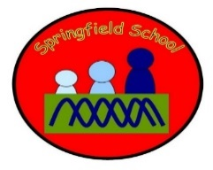 Badgers Class Medium Term Planning for History and Geography Summer Term 2024
Topic  Explorers  Geography- Where have explorers been  History – Explore some famous explorers | History and Geography will have a dedicated slots or be incorporated into other lessons including English through texts, art and Design Technology each week. There will be specific planned opportunities to support the children’s progress and may be altered to suit the needs of the children during the term.  Continuous provision will also enhance the opportunities to learn about Explorers through play

Week 1  Look at video of climbers on Everest and original.  Make model Everest  Use Makaton each week | Week 2  Look at video of Amelia Earhart flying and abut to fly . Fly model planes, explore toy planes  Use Makaton each week | Week 3  Watch video of first moon landing and Buzz Aldrin. Make models of the Moon and rockets. Launch with countdown using toy rockets or models made | Week 6  Explore different modes of transport used by Nellie Bly to travel around the World in less than 80 days  David Attenborough, Amelia Earhart, Gertrude Ederle, Nellie Bly. | Week 7  Gertrude Ederle – Fist woman to swim the English Channel  Watch video and explore swimming with dolls in Tuff tray and accompanying boat

Take the objectives for the LO stickers from this section
Substantive Knowledge (Content) | Disciplinary Knowledge (Skills)
Children learn about new environments  Children learn that people can be explorers  Learn to explore | - Show attention to explorers and environments  - Explore and engage in the sensory and physical aspects of exploring  - .

