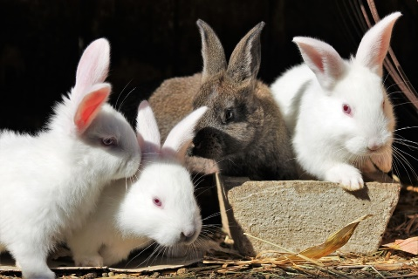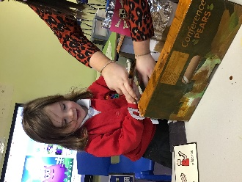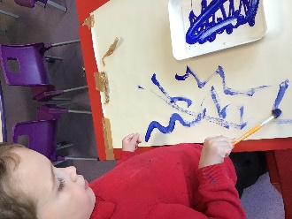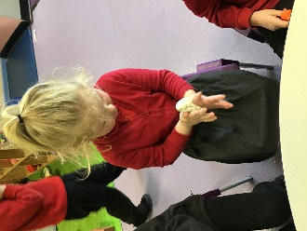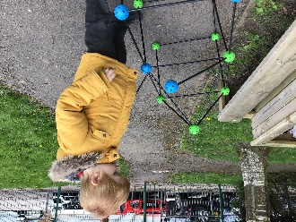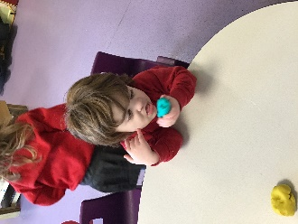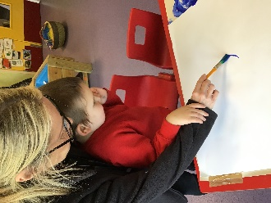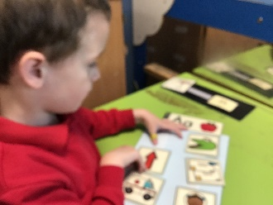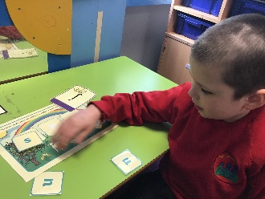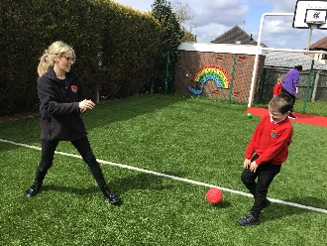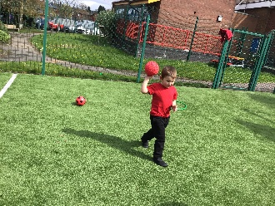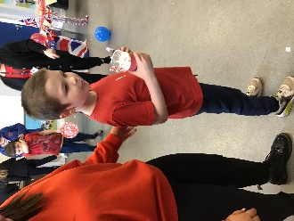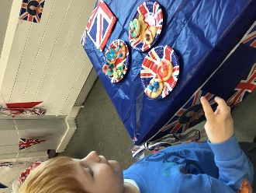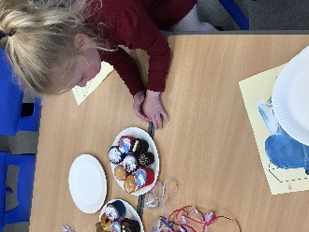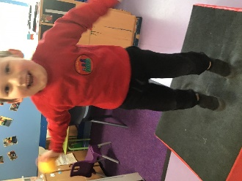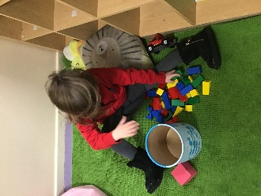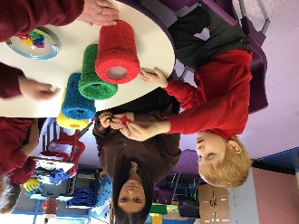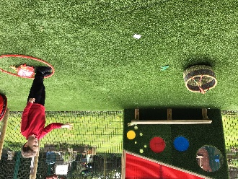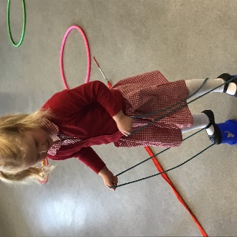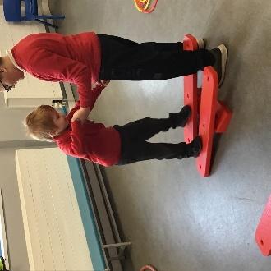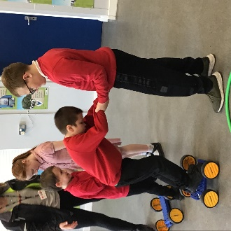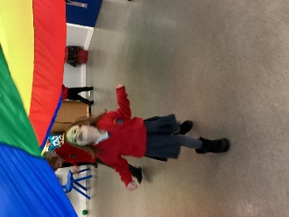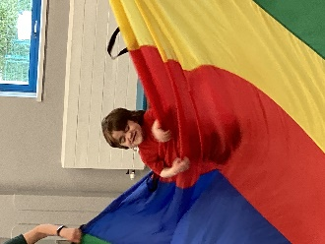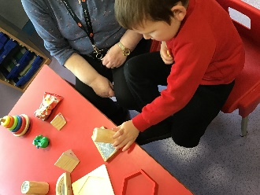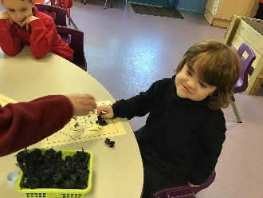

Rabbits Blog

Autumn 1

Rabbits have settled in well to their new class this half term. They have been learning their routines, getting used to the school and have been making friends! Rabbits staff have been very impressed how fast everyone has settled in and how much progress they have made already. We have been doing lots of activities and we especially love the messy ones!

This half term we have learned lots of new things. In Maths we have been exploring colour, shapes and number. We are very good at sorting colours and matching numerals. In English, we have been focusing on our mark making – we love making marks with our fingers using paint or creating prints using fruit. We have also been practising PECs (a lot). We are really getting the hang of exchanging a photograph and getting what we ask for. Our favourite day is Friday as we get to go on the iPads.

Our topic this half term has been ‘Marvellous Me’. We have been learning all about ourselves, looking at ourselves in mirrors and learning about our body parts. We really enjoy listening to our class stories, they are called ‘Marvellous Me’ and ‘What Makes Me a ME?’. We are able to pay attention for a longer period of time now.

This last week we have been focusing on Halloween and have completed lots of activities based on the tradition. We have explored pumpkins, made puffy ghosts and have done some erupting pumpkins in our Attention Autism sessions.

We hope everyone has a lovely half term, you have all worked very hard and deserve the break! We will be doing even more learning next half term and we will get even messier!

